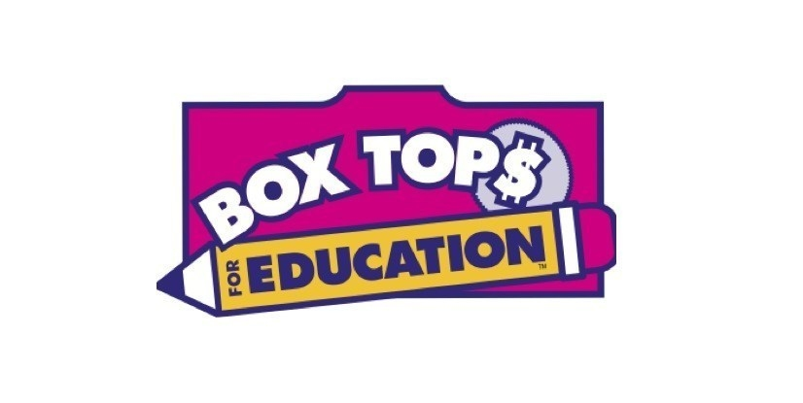
Welcome back to school, Folsom Families! My name is Madeline Milton and I am thrilled to be our school’s Box Tops for Education™ Coordinator.

Clipping Box Tops is an easy way to help earn cash for our school. Each Box Top is worth 10 cents for our school! Just look for the pink Box Tops on hundreds of products. All you have to do is clip them, put them in a baggie labeled with your child’s name and teacher’s name and send them to school. The students will place them in the Box Tops bucket located in the Front Office.

For more information on Box Tops, including a list of participating products, go to BTFE.com.

Thank you for your help!
Madeline Milton

Welcome back to school, Folsom Families! My name is Madeline Milton and I am thrilled to be our school’s Box Tops for Education™ Coordinator.

Clipping Box Tops is an easy way to help earn cash for our school. Each Box Top is worth 10 cents for our school! Just look for the pink Box Tops on hundreds of products. All you have to do is clip them, put them in a baggie labeled with your child’s name and teacher’s name and send them to school. The students will place them in the Box Tops bucket located in the Front Office.

For more information on Box Tops, including a list of participating products, go to BTFE.com.

Thank you for your help!
Madeline Milton

